BACKEND LEARNING
https://w.amazon.com/bin/view/Retail_Business_Services_%28RBS%29/_RBS_Tech/CAM/InsightsSuite/InsightsCreationTraining/#HTrainingVideos
Go through the above wiki.
- Send email request for the team https://permissions.amazon.com/a/team/cam-away-team for access.
Mail content:
- Amazon Login of people who need access - @Reddy, Gali Jithendranath (gjithend)
- Reason for access – For learning Backend API creation.
- Project you are working on – VGA (Vendor Growth Analytics)
- Time period for which you need access – 04/08/2025 to 04/23/2026
- Away Team Link: https://permissions.amazon.com/a/team/cam-away-team

- S3 – cam-sandbox-devo-182399682995 – create your folder with ‘gjithend’
- https://code.amazon.com/packages/RBSCamMaestroCDK/trees/mainline

----------------------------------------------------------------------------------------------------------------------------------------------------------------------------------------------------------------------------------------------------------------------------------------------------
SSH:
DEV DESKTOP: https://ssh.corp.amazon.com/?tabs=dev-dsk-gjithend-cdd-1d-62abe21d.us-east-1.amazon.com&ide=false
Powershell:
>> ssh-keygen -t ecdsa -f C:\Users\gjithend\.ssh\id_ecdsa
- This command creates private and public keys in local laptop.
- Mwinit -o creates ssh certificate using private key so that public key is routed to cloud/remote.
- So when mwinit -o is performed the private key from laptop and public key from remote server are matched and if matched it connects (hence mwinit serves as middle ware initialization).
In your local desktop, in this folder C:\Users\gjithend\.ssh
Make sure you have only these files:
"C:\Users\gjithend\.ssh\config"
"C:\Users\gjithend\.ssh\id_ecdsa"
"C:\Users\gjithend\.ssh\id_ecdsa.pub"
"C:\Users\gjithend\.ssh\id_ecdsa-cert.pub" (this file will be generated by mwinit -o)
>> mwinit -o
>> ssh gjithend@dev-dsk-gjithend-cdd-1d-62abe21d.us-east-1.amazon.com
>> ssh -i C:\Users\gjithend\.ssh\id_ecdsa -i C:\Users\gjithend\.ssh\id_ecdsa-cert.pub gjithend@dev-dsk-gjithend-cdd-1d-62abe21d.us-east-1.amazon.com

VSCODE SSH:
ssh gjithend@dev-dsk-gjithend-cdd-1d-62abe21d.us-east-1.amazon.com

----------------------------------------------------------------------------------------------------------------------------------------------------------------------------------------------------------------------------------------------------------------------------------------------------
https://ssh.corp.amazon.com/?tabs=dev-dsk-gjithend-cdd-1d-62abe21d.us-east-1.amazon.com&ide=false
Setup a workspace with RBSCamMaestroCDK package using the below commands
brazil ws --create --name RBSCamMaestro --vs RBSCamMaestro/development
cd RBSCamMaestro
brazil ws --use -p RBSCamMaestroCDK
- /home/gjithend/workplace/RBSCamMaestro/src/RBSCamMaestroCDK/configuration/artifacts/brazil-config/app/RBSCamMaestro.cfg – to see cluster, profile configurations.
- Examples definitions: /home/gjithend/workplace/RBSCamMaestro/src/RBSCamMaestroCDK/exampledefinitions
- Local development- Sandbox /home/gjithend/workplace/RBSCamMaestro/src/RBSCamMaestroCDK/definitions/sandbox
- Beta and Prod: /home/gjithend/workplace/RBSCamMaestro/src/RBSCamMaestroCDK/definitions/profiles
- .json, .sql files should have same names.
- /home/gjithend/workplace/RBSCamMaestro/src/RBSCamMaestroCDK/configuration/artifacts/brazil-config/app/RBSCamMaestro.cfg
- Uncomment line 15
- In Terminal: cd /home/gjithend/workplace/RBSCamMaestro/src/RBSCamMaestroCDK
- In Terminal: bdtmaestro sandbox-deploy
Error: bdtmaestro not found
In Terminal:
- mwinit -o
- toolbox registry add s3://bdt-maestro-tools/tools.json
- toolbox install bdtmaestro
- toolbox update bdtmaestro
- bdtmaestro
- kinit -f && mwinit -o –aea
- npm -v (npm appeared in my cloud may be because of this /bin/bash -c "$(curl -fsSL https://raw.githubusercontent.com/Homebrew/install/HEAD/install.sh)")
- npm install -g aws-cdk
- bdtmaestro sandbox-deploy
- >> brazil-build clean
- >> brazil-build
- >> bdtmaestro sandbox-deploy

This command didn’t work in VS code, but worked in SSH cloud.
IN VS CODE:
- Fails
- Then update the account details
- /home/gjithend/workplace/RBSCamMaestro/src/RBSCamMaestroCDK/lib/datapipeline-config.yaml
Line number 4, change account id.( 182399682995).

“ada credentials update --account=182399682995 --provider=conduit --role=CAMAwayTeamAccessRole --profile=default --once”
ada credentials setup
cat ~/.aws/credentials

kinit -f && mwinit -o –aea
bdtmaestro sandbox-deploy

BUILD SUCCEEDED
Start deploy changes to sandbox stage

Running: cdk deploy --app build/cdk.out RBSCamMaestro-SB
[ERROR] Sandbox Deployment failed. Cannot run program "cdk": error=2, No such file or directory

curl -o- https://raw.githubusercontent.com/creationix/nvm/v0.33.11/install.sh | bash

=> Close and reopen your terminal to start using nvm or run the following to use it now:

export NVM_DIR="$HOME/.nvm"
[ -s "$NVM_DIR/nvm.sh" ] && \. "$NVM_DIR/nvm.sh" # This loads nvm
[ -s "$NVM_DIR/bash_completion" ] && \. "$NVM_DIR/bash_completion" # This loads nvm bash_completion

nvm -v

nvm install node –lts

doesn’t work

nvm install iojs-v3.3.1
Run `nvm use --delete-prefix iojs-v3.3.1` to unset it.

npm install -g aws-cdk

- after this there should be a Maestro-test profile in cam-sandbox cradle account, saying deployment is done.
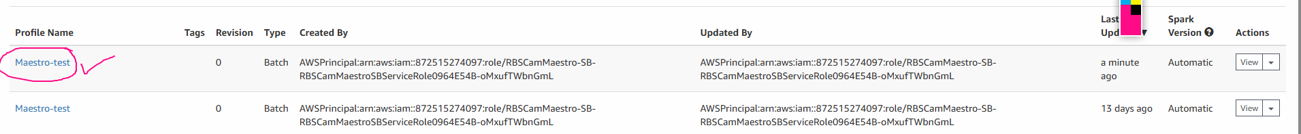

Create profiles here:

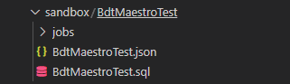

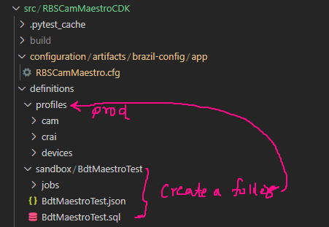
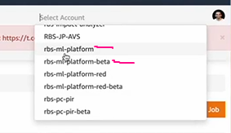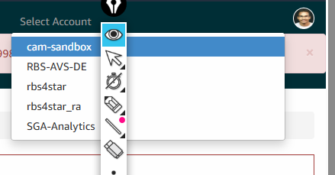

NOTE: Andes, S3 inputs and outputs and different clusters inputs etc… need a document.

- Raise a CR

---------------------------------------------------------------------------------------------------------------------------------------------------------------------------------------------------------------------------------------------------------------------------------------------------- Deploying data in sandbox S3 for testing the API:
- line 15: sandbox.*.CRADLE_ACCOUNT_NAME = "cam-sandbox";
uncomment this line in config file.we might have commented this for raising CR.
- AccountID | - 182399682995
- stage | - box
- Do these changes in Job, for sandbox job.

Change the S3 output location:
"outputs": [
{
"type" : "S3",
"bucketName" : "rbs-cam-insights-input-sand${stage}-${AccountID}",
"keyName" : "vendorGrowthAnalytics/asinReviewTrends/${marketplace_id}/weekly/#{formatDate(#datasetDate,\"YYYY-MM-dd\")}",
"dataFormat" : "JSON",
"compressFile" : false,
"includeHeader" : false,
"saveMode" : "OVERWRITE"
}

Note: If human modifies the profile or job in sandbox, later when you run “bdtmaestro sandbox-deploy” doesn’t do any changes in cradle.

Once the S3 is loaded with data, step function gets triggered.
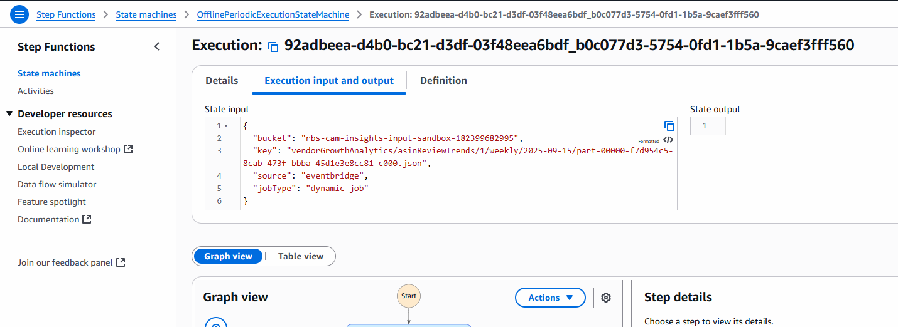
After Step Function succeeds, go to API Gateway:
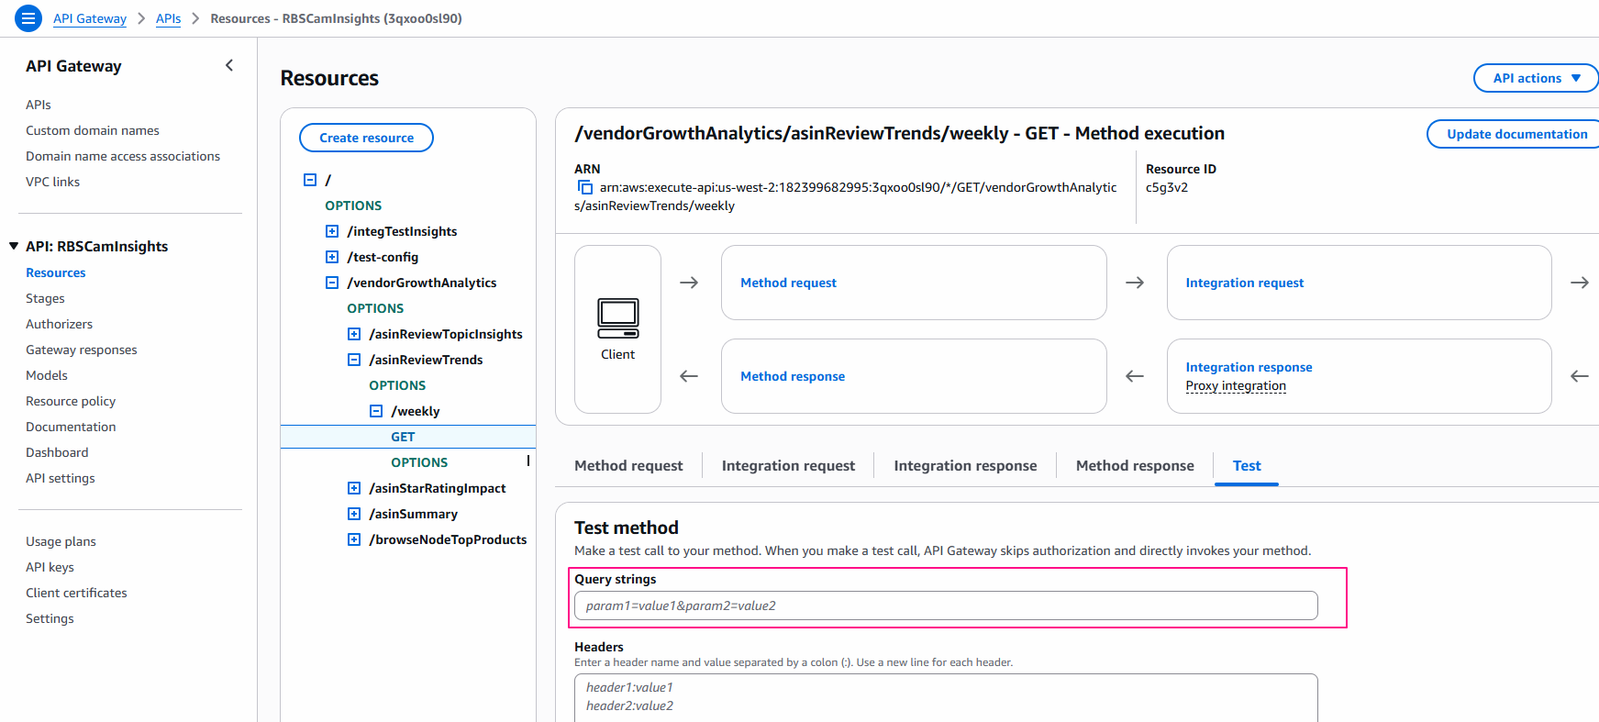
In query strings, enter this: asin=B09MRLV31W&marketplace=1&forceLatestRunData=true
Test your API .
----------------------------------------------------------------------------------------------------------------------------------------------------------------------------------------------------------------------------------------------------------------------------------------------------
Prod FILES:

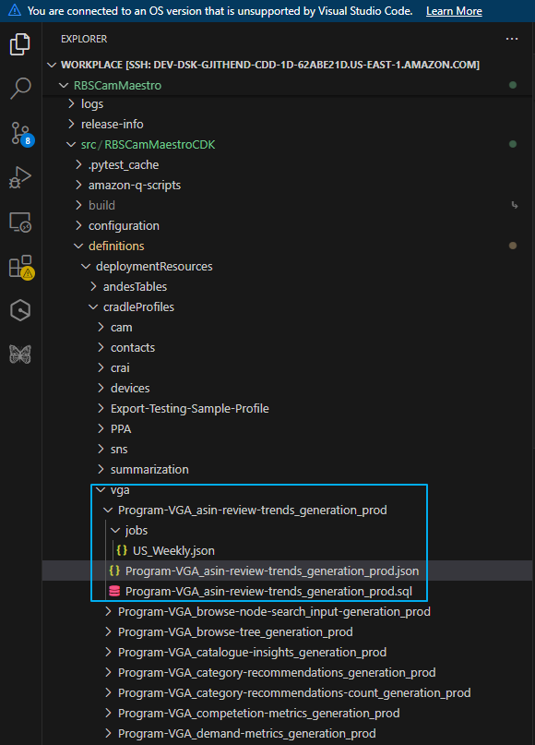
File1: Program-VGA_asin-review-trends_generation_prod.json:

File2: Program-VGA_asin-review-trends_generation_prod.sql

File3: US_Weekly.json

File4: /home/gjithend/workplace/RBSCamMaestro/src/RBSCamMaestroCDK/configuration/artifacts/brazil-config/app/RBSCamMaestro.cfg
----------------------------------------------------------------------------------------------------------------------------------------------------------------------------------------------------------------------------------------------------------------------------------------------------
RAISE CR AND MERGE:
>> git pull origin mainline
>> git branch
>> git fetch origin → gets the latest data (but doesn’t merge).
>> git pull origin mainline → brings in all latest changes into your local branch.
Error:
Answer:

Syncing the versionset with local changes:

>> git checkout mainline
>> git fetch origin
>> git reset --hard origin/mainline
>> brazil-build clean
>> brazil-build

Make the changes you want.
>> git status
>> git add .
>> git commit -m "Your message describing the change"
>> cr

- For CR description:

>> git fetch origin
>> git checkout mainline
>> git merge origin/mainline
4️⃣ Review & resolve conflicts (if any)
>> git add <file>
>> git commit -m “message”
>> cr
MERGED
- Make sure the origin(versionset) and mainline (local changes) are in sync meaning, the latest commit has to be taken when you raise cr for merge.

REFERENCE:
Cradle UI deployment errors:
https://datacentral.a2z.com/jobs/manage-pipelines/Deployments/datapipelineName/RBSCamMaestro/stageName/Sandbox/deploymentId/1760619817567
https://smores-na.integ.amazon.com/vendor/groups/detail?vendorGroupId=288377&successMessage=Successfully%20activated%20vendor%20group!
https://vendorcentral-us.integ.amazon.com/caminsightsbackend/vendorGrowthAnalytics/asinReviewTrends/weekly?asin=B09MRLV31W&marketplace=1&forceLatestRunData=true

Queries:
- If we manually edit profiles/job in cam sandbox and later want to update version by package, create a new folder in sandbox folder and create a new profile.
- If you have multiple columns like csv, step function takes lot of time, if it is like JSON struct – it takes less time.
- to know which execution is yours in step function -> click on execution -> check the tab “Execution input and output”.

